Activity 1.3.1 Solar Hydrogen System – VEX

A third of the energy used by people is used for transportation - mostly fueled by gasoline, diesel, and jet fuel, which we get from petroleum. To use another source of energy like wind, solar, or nuclear energy, the energy must be stored so that it is available on the vehicle. | Hydrogen storage and transportation  U.S. Department of Energy
Equipment
- Solar hydrogen automobile
- Hydrogen fuel cell
- Solar module
- Distilled water
- Wires
- Multimeter or other probes for measuring voltage and current
- Light with a 120 Watt incandescent bulb, or as recommended in the manufacturer’s instructions
Procedure
Most of the universe is made out of hydrogen, but the hydrogen on Earth is chemically bonded to other elements. Hydrogen is bonded to oxygen, for instance, to make water: H₂O. Pure hydrogen, H₂, is a gas that contains more energy compared to hydrogen that has bonded with other elements. Hydrogen gas can be burned in oxygen to produce heat; in a fuel cell, this same chemical reaction occurs in a controlled way so that it produces electricity. Fuel cells require a platinum catalyst – the same material used in cars’ catalytic converters. Platinum is among the earth’s most expensive metals, and engineers and scientists are working to find ways to use other materials to decrease the cost of fuel cells. With this research, we hope one day to use hydrogen to store energy from other sources so that we can supply our electricity and transportation needs using alternatives to fossil fuels.

In this activity your team will power a small vehicle using different power sources: a solar panel, a fuel cell, and a battery. You will use the electricity from the solar module to separate hydrogen from oxygen, harness the hydrogen, and then use the hydrogen as fuel.

This activity was written to be used with the Heliocentris fuel cell. If you are using fuel cells from a different manufacturer, refer to that manufacturer’s instructions to be sure that the equipment is used as designed.  - Read the Fuel Cell User Guide.  - Follow the directions in the Fuel Cell User Guide under the section Preparing the Fuel Cell for Use. | 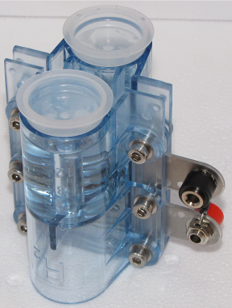
- Attach the solar panel to your vehicle and connect the motor leads to the solar module. Holding your vehicle off the ground, is there enough power generated from the sunlight to turn the motor?
If so, is there enough power to turn the motor with the wheels on the ground?
- Set your multimeter to measure voltage. Connect the multimeter test leads to the solar module terminals.  Record the load voltage. You will need to hold your vehicle off the ground to do this.  V = Load Voltage _________ | 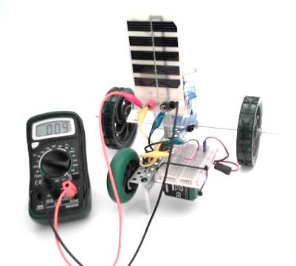
- Energize the fuel cell by using the directions in the Fuel Cell User Guide.  After the fuel cell is energized, attach the fuel cell to the motor using the breadboard to make the connections. Holding your vehicle off the ground, is there enough power to turn the motor?  If so, is there enough power to turn the motor with the wheels on the ground? | 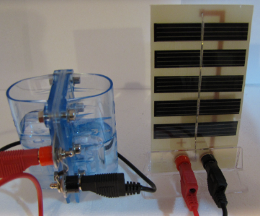
- Set the multimeter to measure voltage. Connect the multimeter test leads to the fuel cell terminals.
Record the voltage value. You will need to hold your vehicle off the ground to do this.
V = Load Voltage __________

